**HR Analytics Dashboard Using Power BI**

**1. Project Overview**

**The HR Analytics Dashboard is a powerful tool designed to analyze employee attrition patterns and provide actionable insights to enhance workforce retention. Using Power BI for visualization and Excel for data preprocessing, the dashboard enables HR managers to identify key trends and develop strategies to optimize workforce management effectively.**

**2. Objectives**

* **Understand and analyze factors influencing employee attrition.**
* **Provide data-driven insights to reduce turnover and enhance employee satisfaction.**
* **Support HR decision-making with interactive dashboards and key performance indicators (KPIs).**

**3. Technologies Used**

* **Power BI: For creating interactive and visually appealing dashboards.**
* **Excel: Used for initial data cleaning and transformation.**

**4. Dataset Description**

**The dataset comprises 1,470 rows and 38 attributes, capturing various aspects of employee information, such as demographics, job satisfaction, performance metrics, and attrition. Key attributes include:**

* **Attrition: Indicates whether an employee has left the organization.**
* **Age, Gender, and Marital Status: Demographic information for workforce analysis.**
* **Job Role and Department: Details about the employee's position and organizational function.**
* **Business Travel: Frequency of work-related travel.**
* **Satisfaction Ratings: Metrics for job satisfaction, environment satisfaction, and work-life balance.**
* **Years at Company: Tenure with the organization.**
* **Monthly Income: Employee compensation.**

**5. Dashboard Overview**

**The dashboard is structured into two main pages, each addressing specific aspects of employee data:**

**Page 1**

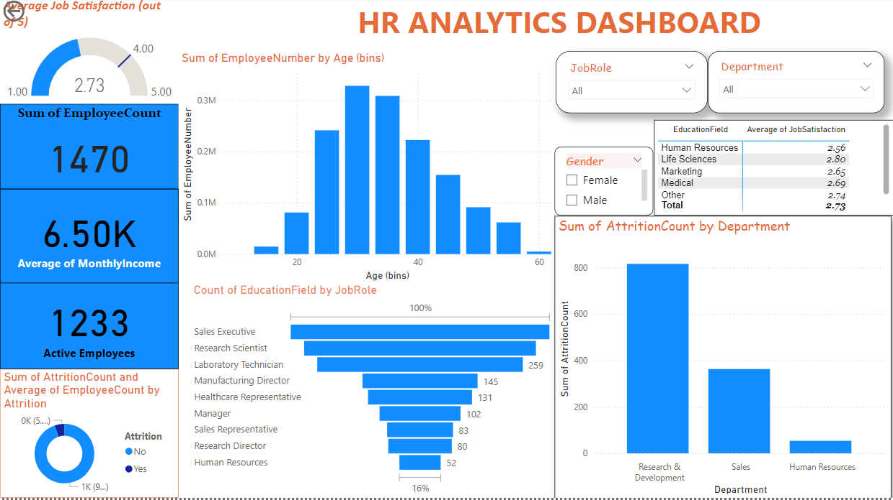

**Dashboard Highlights**

**General Overview and Demographics**

* **KPIs:**
  + **Total Employees: 1,470**
  + **Active Employees: 1,233**
  + **Attrition Count: 237 (16.12% attrition rate)**
  + **Average Job Satisfaction: 2.73 out of 5**
  + **Sum Monthly Income: 9.56M**
* **Key Visualizations:**
  + **Average Job Satisfaction: Displayed as a gauge with a value of 2.73 out of 5.**
  + **Sum of EmployeeCount: Displayed as 1470 employees.**
  + **Average of MonthlyIncome: Displayed as 6.50K.**
  + **Active Employees: Displayed as 1233 employees.**
  + **Age Distribution: Bar chart showing the distribution of employee numbers across different age bins.**
  + **Education Field by Job Role: Horizontal bar chart showing the count of employees in different job roles.**
  + **Attrition Count: Donut chart showing the attrition count and average employee count by attrition status.**
  + **Attrition by Department: Bar chart showing the attrition count across different departments.**
  + **Job Satisfaction by Education Field: Table showing the average job satisfaction for different education fields.**
  + **Filters: Dropdowns for JobRole and Department, and checkboxes for Gender (Female and Male).**
* **Key Insights:**
  + **Employees aged 25–34 form the largest group experiencing attrition.**
  + **Departments with lower satisfaction scores correlate with higher attrition rates.**

**Page 2**

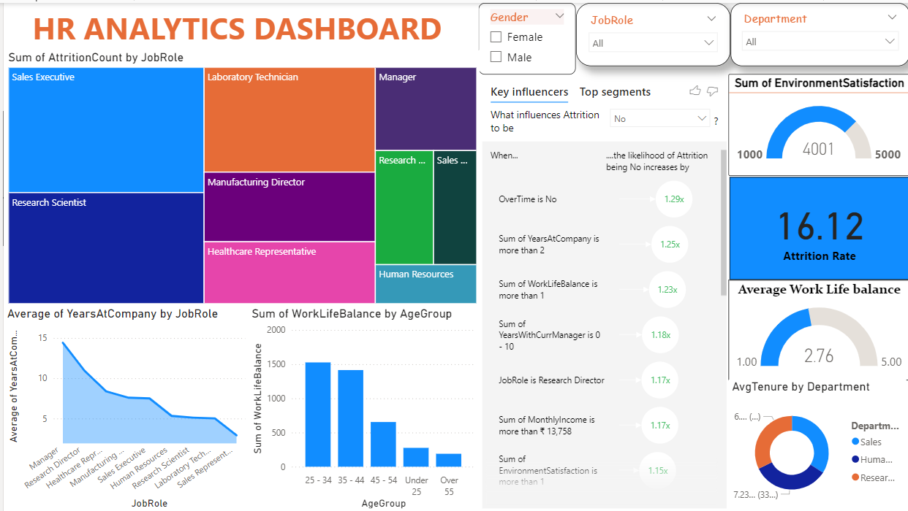

**Overview of Page 2 Visuals**

1. **Sum of AttritionCount by Job Role: A treemap showing the count of attrition events for different job roles such as Sales Executive, Laboratory Technician, Manager, Research Scientist, Manufacturing Director, Healthcare Representative, and Human Resources.**
2. **Average of YearsAtCompany by Job Role: A line chart depicting the average number of years employees stay at the company for different job roles.**
3. **Sum of WorkLifeBalance by AgeGroup: A bar chart showing the sum of work-life balance scores for different age groups (Under 25, 25-34, 35-44, 45-54, Over 55).**
4. **Key Influencers for Attrition: A section listing factors influencing the likelihood of attrition, such as overtime status, years at the company, work-life balance, years with the current manager, job role, monthly income, and environment satisfaction.**
5. **Sum of EnvironmentSatisfaction: A gauge showing the total environment satisfaction score, which is 4001 out of 5000.**
6. **Attrition Rate: A metric showing the attrition rate, which is 16.12%.**
7. **Average Work-Life Balance: A gauge showing the average work-life balance score, which is 2.76 out of 5.**
8. **Average Tenure by Department: A donut chart showing the average tenure by department, with specific values for Sales, Human Resources, and Research.**

**DAX:AvgTenure = AVERAGE('HR Attrition'[YearsAtCompany])**

**Documentation Summary**

**This documentation outlines the key visuals on your HR Analytics Dashboard and explains their purpose and setup. The dashboard is designed to provide comprehensive insights into employee data, helping the organization make informed decisions.**

**7. Key Insights**

1. **Demographics:**
   * **Younger employees (<25 years) and single employees have higher attrition rates.**
2. **Departmental Trends:**
   * **Research & Development has the highest attrition and needs targeted retention strategies.**
   * **Human Resources exhibits lower attrition and can serve as a benchmark.**
3. **Role and Income:**
   * **Sales Representatives and Laboratory Technicians face higher attrition due to lower income levels.**
   * **Higher-paid employees, such as Managers, are more likely to stay.**
4. **Satisfaction and Travel:**
   * **Low job satisfaction ratings are strongly linked to higher turnover.**
   * **Employees with frequent travel commitments show moderate attrition levels.**

**8. Recommendations**

**To address the identified challenges and improve workforce retention:**

* **Targeted Onboarding Programs: Enhance support for new hires through structured mentoring and integration plans.**
* **Tailored Retention Strategies: Focus efforts on departments and roles with high attrition, using HR benchmarks for comparison.**
* **Job Satisfaction Improvement: Conduct regular surveys to boost engagement, especially for roles with high dissatisfaction.**
* **Work-Life Balance Initiatives: Mitigate travel fatigue with policies offering flexible work arrangements.**
* **Compensation Review: Adjust salaries for lower-paid roles to align with industry standards.**

**9. Conclusion**

**The HR Analytics Dashboard serves as a comprehensive tool for understanding and addressing employee attrition. By leveraging insights from this analysis, organizations can develop targeted strategies to improve retention, enhance employee satisfaction, and ultimately drive organizational performance. The integration of advanced analytics and visualization empowers HR teams to make data-driven decisions, reduce turnover costs, and build a resilient workforce.**